TAGORE DENTAL COLLEGE AND HOSPITAL
DEPARTMENT OF ORAL PATHOLOGY

PROGRAM CATEGORY | Guest Lecture
TOPIC | Fibro Osseous Lesion
DATE | 05/05/2021
DAY | Wednesday
VENUE | Google meet
ORGANIZERS | Department of Oral Pathology
NUMBER OF PARTICIPANTS | III BDS – 56 students
RESOURCE PERSON | Dr. J. Muruganandhan

TAGORE DENTAL COLLEGE AND HOSPITAL
DEPARTMENT OF ORAL AND MAXILLOFACIALPATHOLOGY

GUEST LECTURE REPORT – 05.05.21

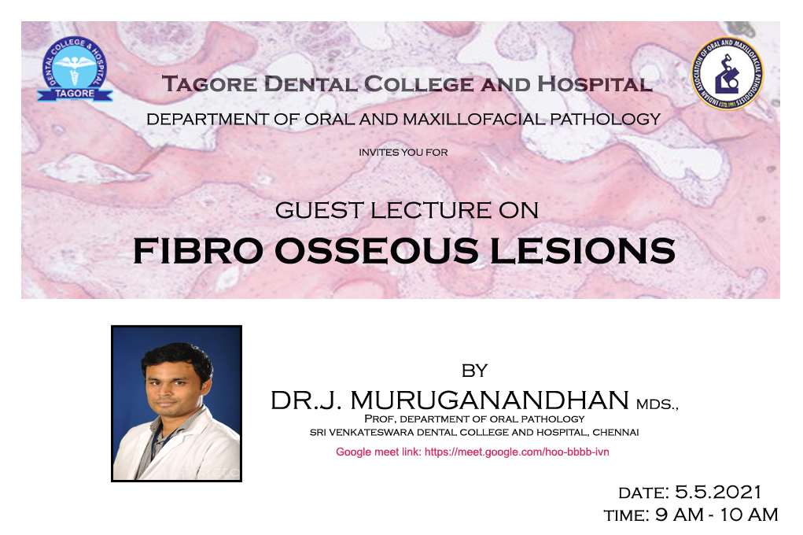
Guest lecture on “Fibro osseous lesions” by Dr.J. Muruganadhan, M.D.S, (Prof. Dept of Oral Pathology, Sri Venkateswara Dental College & Hospital) was organized by Department Of Oral Pathology. The lecture was attended by 56 third year students ( Regular and Additional batch). Introduction, classification,clinical, radiographic and histopathology and treatment modalities for fibro osseous lesions. The speaker of the day was falicitated with certificate.

PHOTO GALLERY

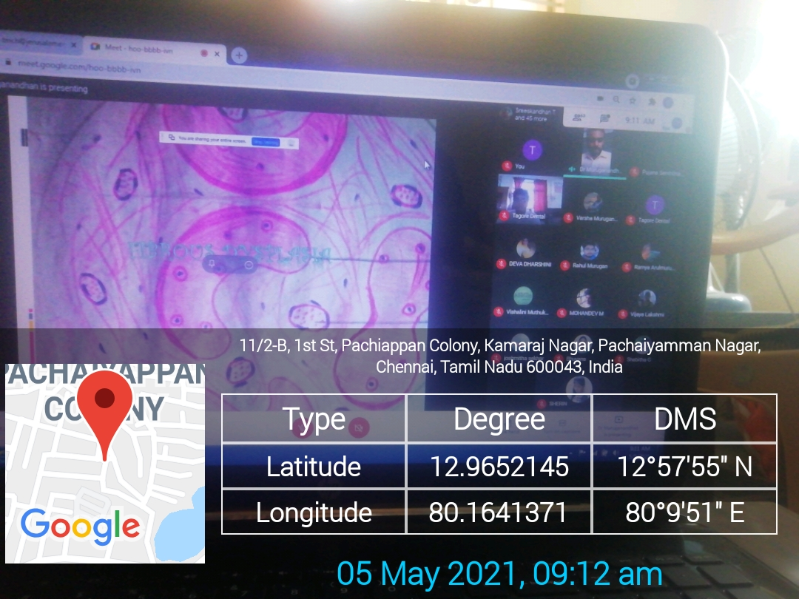

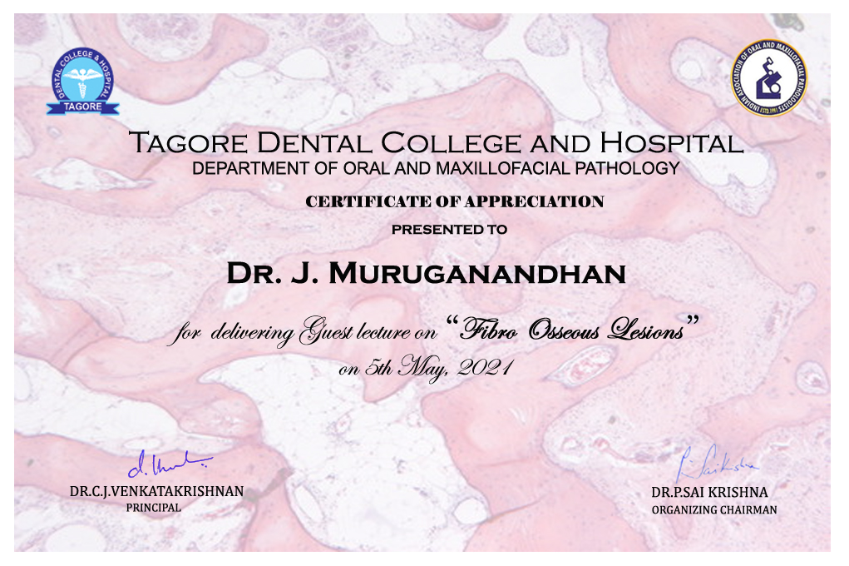
CERTIFICATE FOR THE SPEAKER

ATTENDANCE:
Topic: Fibro osseous lesions
Time: 9 to 10 AM
Total students -64 (Regular batch - 56/Additional batch - 8)
Today present- 56/Today absent - 8

Absentees names:
Additional batch
1.swetha ravi
2.abimithra
3.Bharani
4.Monisha
5.suruthi
6. Rubesh

Regular batch
1. Akhila
2.Elamaran

